Tab 1

Applicant
Rohan Manchanda

Title of the Invention
A Bio-Inspired Hybrid Wheeled and Legged Spider Robot with Adaptive Multi-Terrain Locomotion and Vision-Based Teleoperation System

Date Of Application

Abstract
The invention relates to a bio-inspired hybrid robotic system that integrates both legged and wheeled locomotion to achieve efficient and adaptive movement across diverse terrains. The robot employs a multi-degree-of-freedom (DoF) leg configuration enabling precise gait control through inverse kinematics, combined with wheel-based propulsion for energy-efficient traversal on flat surfaces.
The system includes a microcontroller-based control architecture using an Arduino Nano and a PWM servo driver for synchronized joint actuation, along with DC motors for rolling motion. A real-time vision module using an ESP32-CAM enables remote teleoperation via a wireless interface.
The robot demonstrates improved adaptability, energy efficiency, and operational flexibility, making it suitable for applications such as search-and-rescue, inspection, agricultural monitoring, and exploration.

Field of the Invention
The present invention relates to the field of robotics and autonomous systems, and more particularly to a bio-inspired hybrid locomotion robot capable of operating across multiple terrains using a combination of legged and wheeled mobility, integrated with kinematic control and real-time vision-based teleoperation.

Background of the Invention
Robotic systems designed for real-world deployment face significant limitations in traversing diverse terrains. Conventional wheeled robots offer high efficiency on flat surfaces but are incapable of overcoming obstacles or irregular terrains. Conversely, legged robots provide superior adaptability and stability but suffer from high energy consumption and complex control requirements.
Existing hybrid robotic systems attempt to combine both locomotion modes; however, they often lack:
- Efficient transition mechanisms between locomotion modes
- Precise kinematic control for stability
- Integrated real-time teleoperation systems
- Compact and cost-effective implementation
As described in the IRIS report, legged locomotion introduces computational complexity and energy inefficiency, while wheeled systems lack adaptability in uneven environments .
Accordingly, there exists a need for a compact, energy-efficient, and adaptable robotic system capable of seamlessly integrating both locomotion strategies while maintaining stability and control.

Objects of the Invention
The primary objectives of the present invention are:
- To provide a hybrid locomotion robot capable of both walking and rolling.
- To enable efficient terrain adaptability across uneven and flat surfaces.
- To implement inverse kinematics-based control for precise leg movement.
- To provide real-time remote monitoring and control using a vision module.
- To reduce energy consumption by enabling mode switching between locomotion strategies.
- To develop a compact, lightweight, and scalable robotic platform.

Summary of the Invention
The present invention discloses a bio-inspired hybrid spider robot system comprising:
- A plurality of articulated legs with multiple degrees of freedom
- A set of wheel motors enabling rolling motion
- A microcontroller-based control system configured to execute kinematic algorithms
- A servo driver for synchronized actuation of multiple joints
- A motor driver for controlling wheel motion
- A wireless vision module for real-time video streaming and teleoperation
- A regulated power supply system
- A structural chassis fabricated using lightweight material
The system enables seamless switching between walking and rolling modes, thereby optimizing energy consumption and improving terrain adaptability.

Detailed Description of the Invention

System Architecture
The robotic system comprises:
- Central Controller: Arduino Nano configured to process control logic
- Servo Control Module: PCA9685 PWM driver for synchronized control of multiple servo motors
- Locomotion Actuators:
  - Multiple servo motors forming articulated legs
  - DC gear motors enabling rolling locomotion
- Motor Driver: L298N module for driving DC motors
- Vision Module: ESP32-CAM configured for wireless video transmission
- Power System:
  - 12V battery source
  - UBEC voltage regulator (5V output)
(All architecture details derived from implementation in IRIS report )

Legged Locomotion Mechanism
Each leg comprises three joints:
- Coxa (rotational base joint)
- Femur (load-bearing joint)
- Tibia (extension joint)
The movement of each leg is governed by inverse kinematics algorithms, wherein:
- Desired foot position is computed
- Joint angles are derived mathematically
- Servo commands are generated accordingly
This enables:
- Stable gait execution
- Precise foot placement
- Multi-directional mobility

Wheeled Locomotion Mechanism
The robot includes a plurality of DC gear motors configured to:
- Enable high-speed traversal on flat terrain
- Reduce energy consumption compared to legged movement

Hybrid Locomotion Switching
The system is configured to:
- Dynamically switch between walking and rolling modes
- Optimize performance based on terrain conditions
- Reduce energy usage during long-distance traversal

Vision-Based Teleoperation
The system further comprises:
- An ESP32-CAM module configured to capture and transmit real-time video
- A wireless communication interface enabling bidirectional control
This enables:
- Remote navigation
- Visual feedback-based decision making

Performance Characteristics
Experimental validation demonstrated:
- Rolling speed of approximately 0.6 m/s
- Stable walking over obstacles up to 25 mm
- Reduced power consumption in rolling mode (~35–40%)
- Real-time video latency of approximately 250 ms

Novelty of the Invention
The novelty of the present invention resides in the integrated hybrid locomotion system combining:
- Simultaneous implementation of legged and wheeled locomotion within a compact robotic architecture
- Kinematic-based control (inverse kinematics) applied to a hybrid robot, enabling precise gait and movement
- Dynamic switching between locomotion modes to optimize energy efficiency
- Integration of real-time vision-based teleoperation (ESP32-CAM) within a low-cost embedded system
- Coordinated multi-controller architecture separating motion control and vision processing
Unlike prior systems, the present invention provides a practically deployable, cost-efficient, and compact hybrid robot with both adaptability and efficiency.

Inventive Step (Non-Obviousness)
The inventive step lies in the non-obvious combination and integration of:
- Bio-inspired multi-DOF leg architecture
- Wheel-assisted locomotion for energy optimization
- Real-time kinematic computation using embedded microcontrollers
- Integrated vision-based teleoperation system
A person skilled in the art would not readily combine:
- Inverse kinematics-based leg control with
- Energy-optimized wheeled locomotion switching, and
- Low-latency vision streaming in a compact embedded system
The invention achieves:
- Improved energy efficiency
- Enhanced terrain adaptability
- Reduced system complexity compared to conventional hybrid robots
Thus, the invention demonstrates a technical advancement over existing systems and is not obvious in light of prior art.

Industrial Applicability
The invention is industrially applicable in:
- Search and rescue operations
- Industrial inspection
- Agricultural monitoring
- Defense and surveillance
- Space and planetary exploration

Claims

Claim 1 (Independent Claim)
A hybrid robotic system comprising:
- A plurality of articulated legs with multiple degrees of freedom
- A plurality of wheel motors
- A control unit configured to switch between legged and wheeled locomotion modes

Claim 2
The system as claimed in Claim 1, wherein each leg comprises three joints configured for multi-axis movement.

Claim 3
The system as claimed in Claim 1, wherein the control unit executes inverse kinematics algorithms for determining joint angles.

Claim 4
The system as claimed in Claim 1, further comprising a servo driver configured to control multiple servo motors simultaneously.

Claim 5
The system as claimed in Claim 1, further comprising a vision module configured for real-time video transmission.

Claim 6
The system as claimed in Claim 1, wherein the system dynamically switches locomotion modes to optimize energy consumption.

Claim 7
The system as claimed in Claim 1, further comprising a manipulator arm configured for object handling.

Drawings/Prototype
Circuit
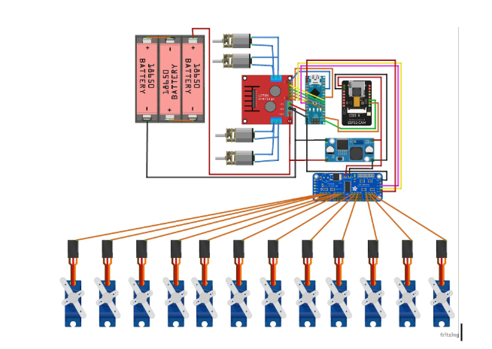

3D Design
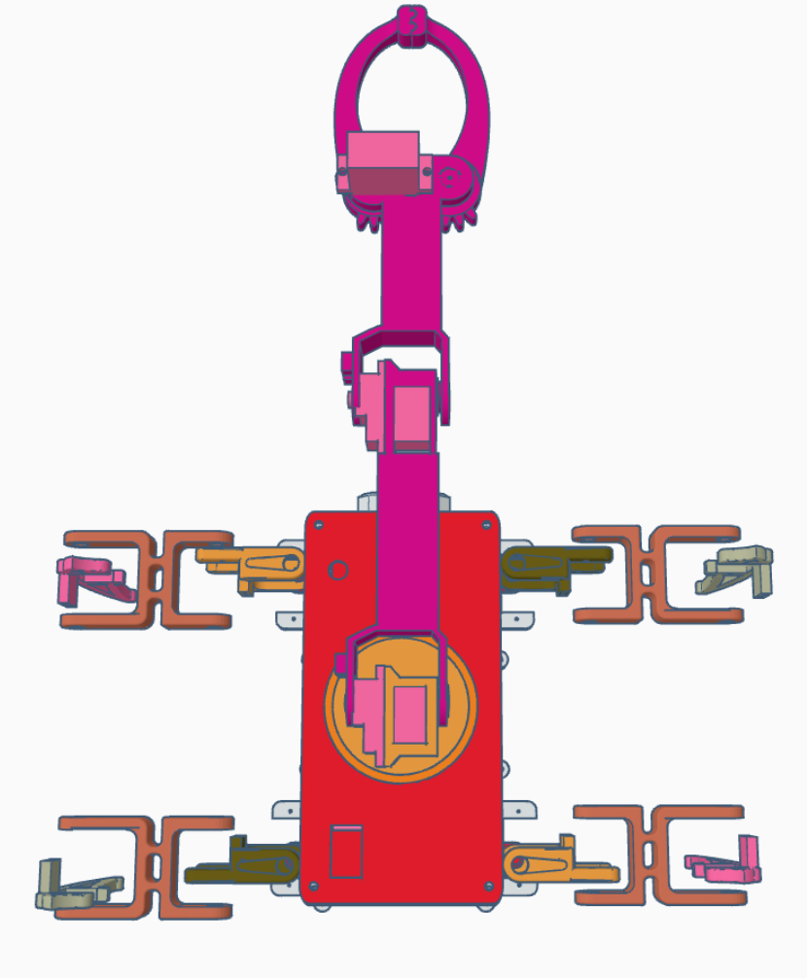

Architecture Diagram
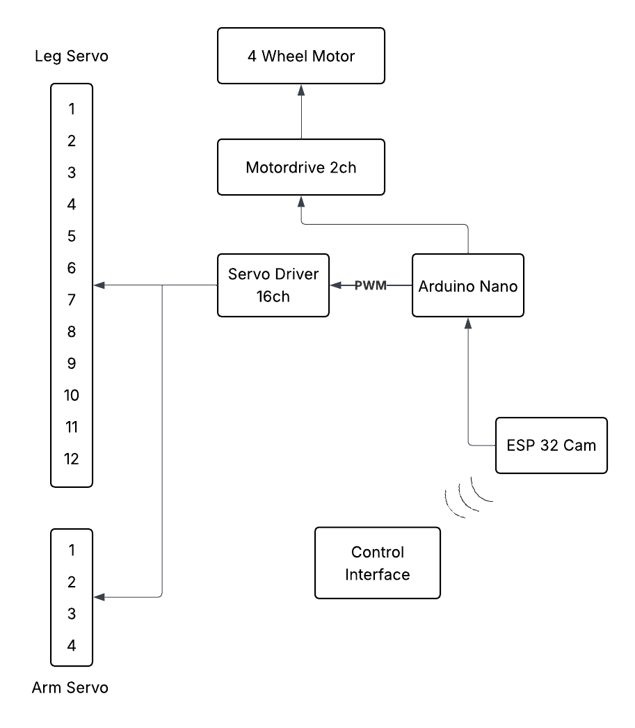

Tab 2
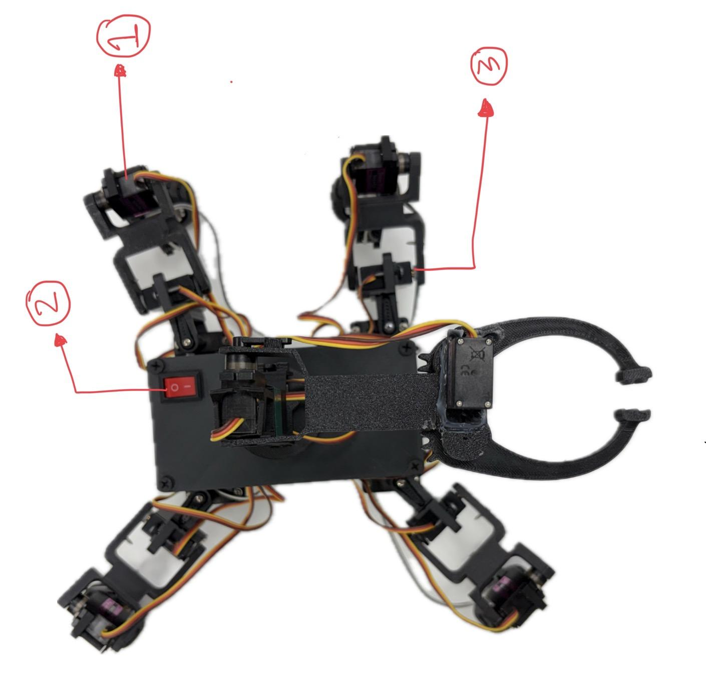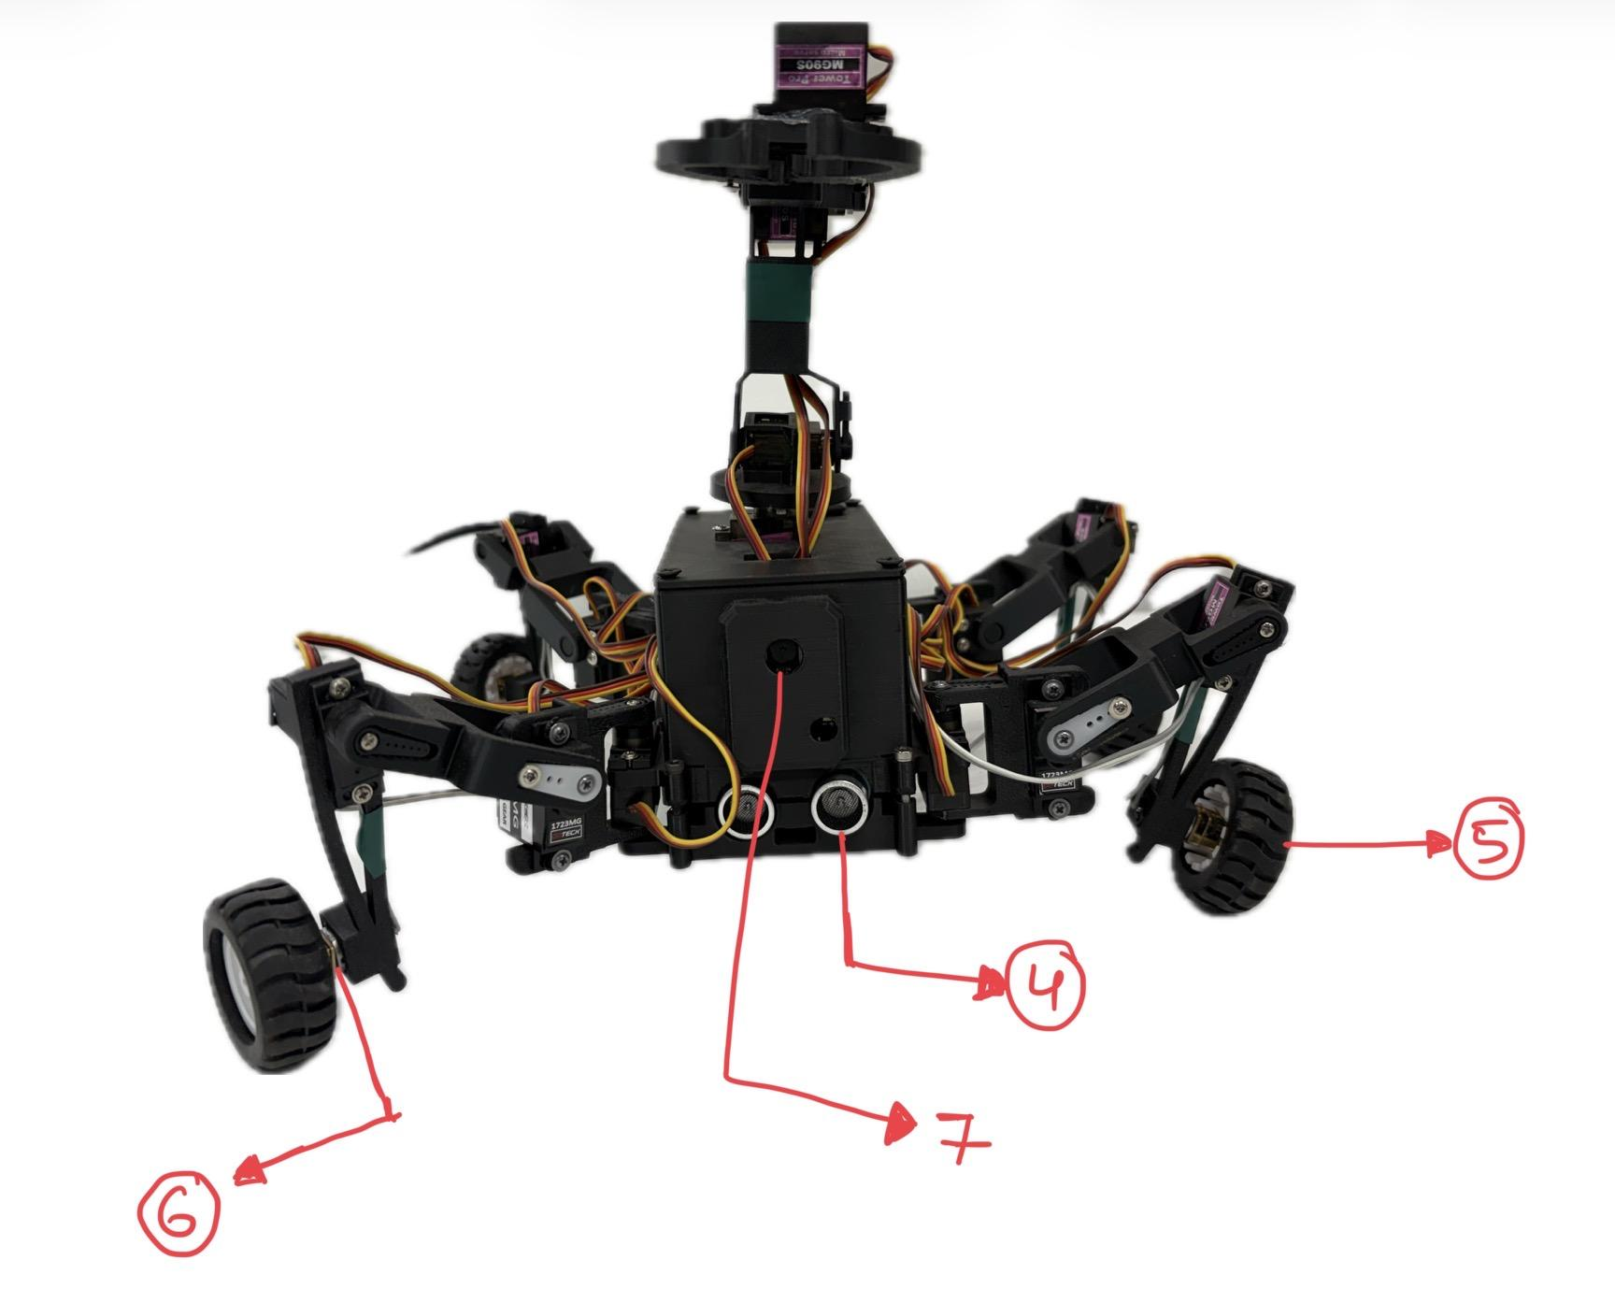
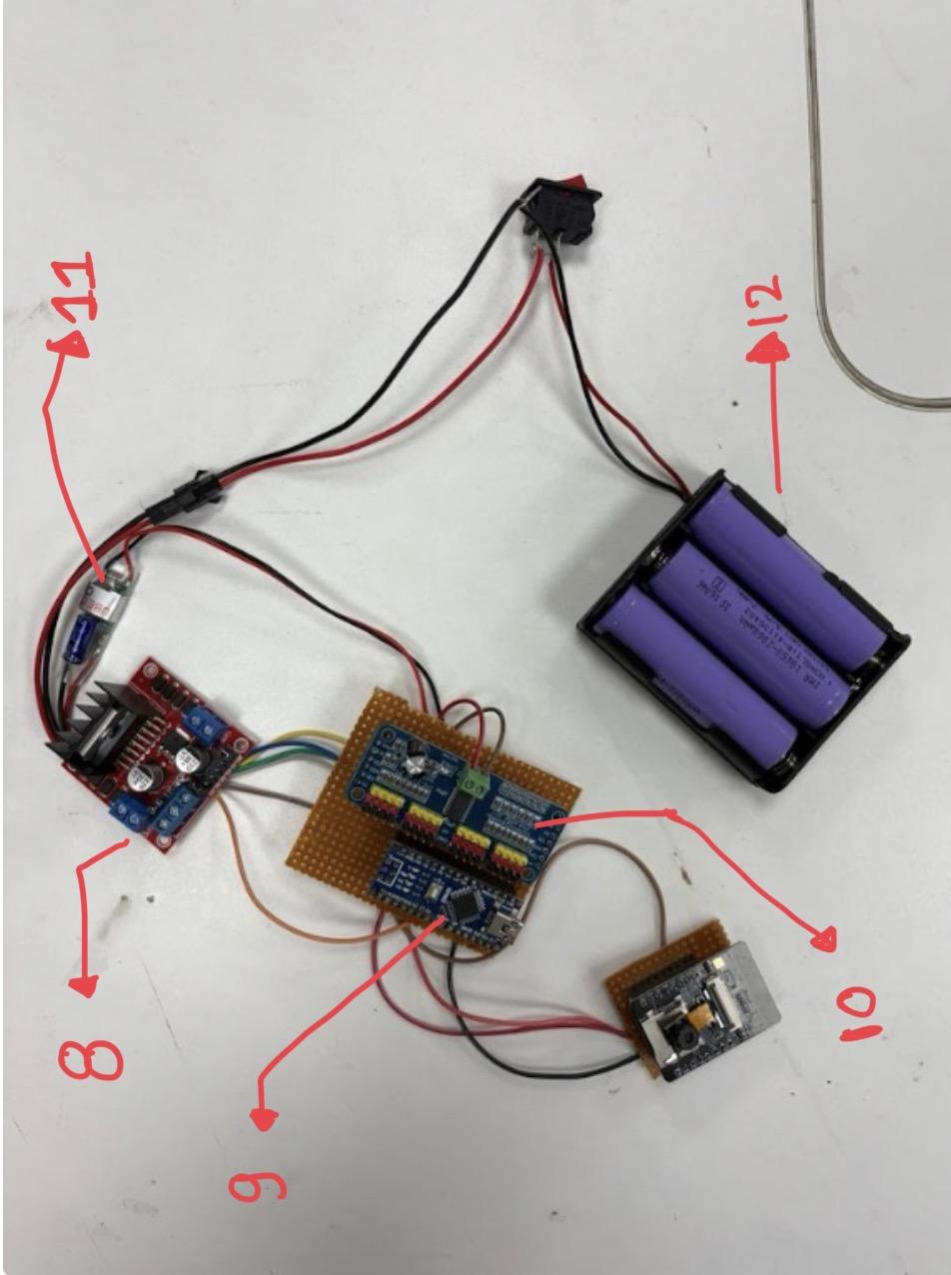

Component List
Serial Number | Component
1 | Mg90s Servo
2 | On off switch
3 | Goteck-1723MG
4 | Ultrasonic
5 | Wheels
6 | N20 Dc geared motor
7 | Esp32 Cam
8 | L298n Motor Driver
9 | Arduino nano
10 | Servo Driver
11 | UBEC Switch
12 | 12V Battery

